Northern Lights Hospital

Phase 2 Integration Project

By:  
Claudio Marricco  
  
Student Code:  
M2893  
  
For:  
 Prof. Zaidi

College CDI  
11/11/2013

Project Description

The purpose of this project was to update the currently used system that the Northern Lights Hospital is using. Having been given a partially started program to draw from had its advantages and disadvantages. The most useful aspect what having a partially started program was having something to draw from visually. The way the forms look aesthetically helped quickly create what the rest of the forms should look like. The way they were formed made sense so it was only natural to draw from them. The code however was a different story. Due to the fact that the program was built for a different database made it difficult to shift through the code to find useful segments. Having understood the general idea of how the logic was supposed to flow, and using snippets of code from the original program, the rest of the program was built mainly from the ground up. Many additional forms needed to be built in order for the system to function as fully needed.

User Documentation

Navigation through the system is designed around the user’s log in credentials. There are 3 types of roles that exist: Doctor, Nurse and Admin. Doctors are given access to general forms and are the only ones allowed to discharge patients. Nurses also have access to the general forms, and are given access to patient lists by ward, and naturally Admin is given access to everything. For the purposes of this documentary, the admin login credentials are “Admin”, and “9999” respectively.

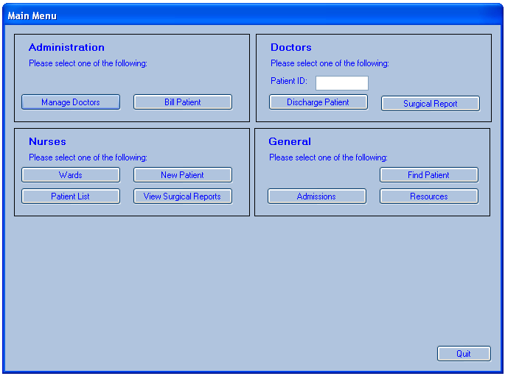

New patients are assigned a ward which the nurses can then assign to a bed or ward if one in that ward is available.

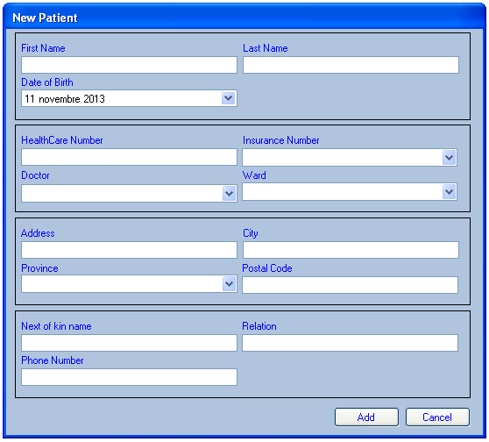

Nurses can view all the patients by ward through the Crystal Reports view available by clicking the “Wards” button. Once on that form, click the “Refresh” button to populate the report with the most current data.

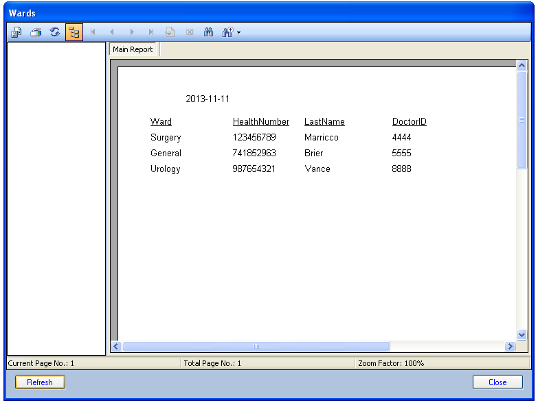

Doctors can submit surgery reports that can later be viewed by Nurses. They can also discharge patients directly from the Main Menu.

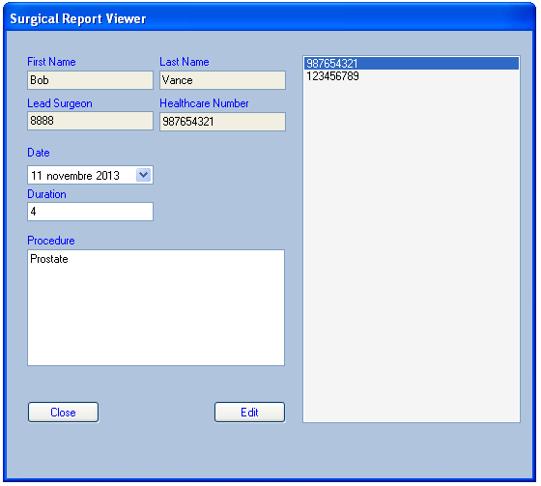

The Admin can manage the current doctors in the system though the “Doctors” form accessible from the Main Menu. Here the Admin can add, edit or delete doctors from the system.

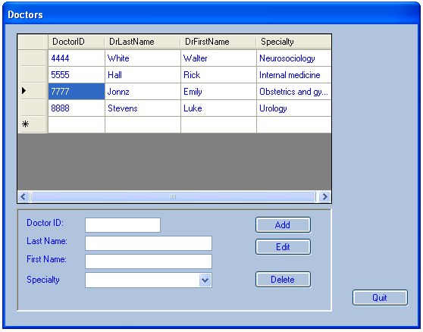

A general user can add a new Admission to the system and then review them for editing. From the main menu screen click on “Admissions” button for the form to open.

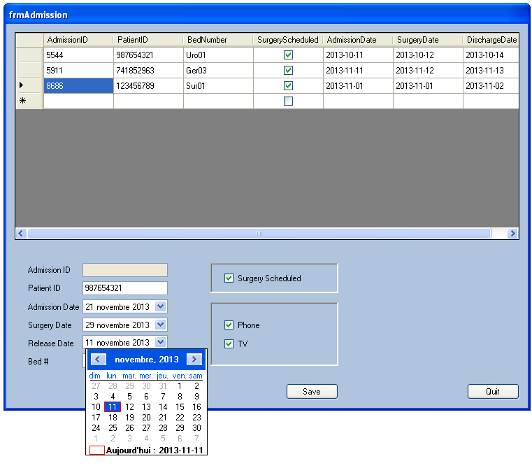

Enter the Patient’s Health Number and the rest of the necessary information to have the patient’s necessary information added to the Admissions database of the Hospital. Clicking “Save” will add the Patient. Double-clicking on a given row will open up a mini screen where the user can Edit the information on that row.

The Admin can also bill a patient. This form collects the information from the patient’s stay at the hospital and calculated how much to charge. The details are all automatically calculated with a list of what they are being charged for. It also calculated how much is covered by their insurance.

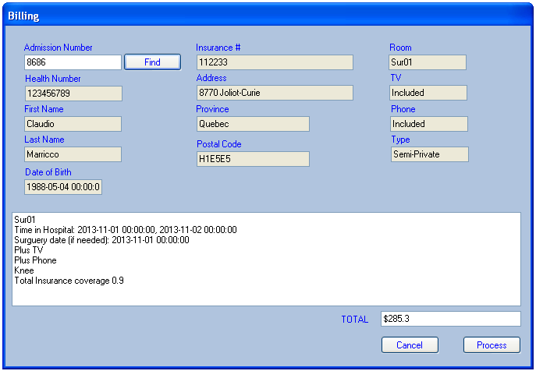

Once reviewing is complete, click on “Process” which will print a receipt and create a copy that is then saved into the NLHospital database.

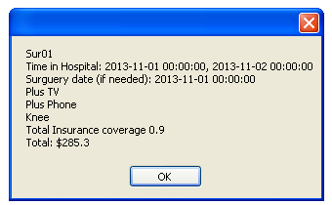

Conclusion

This project required working with SQL closely. Many tables were needed and communicating with multiple tables at once was key in order for this system to function the way it needs to function. Trying to make everything work in unison was probably the most difficult aspect of building this system. There are many factors and a lot of data that needs to be managed in order for this system to perform simultaneously. A lot of that came from having proper tables created in the database. Many tables were needed in order to have the data segregated properly, but having the right amount also helps keeping the data organized without diluting the database. A balance needs to be made in order for it to perform properly. This system does what it’s supposed to do and nothing less.